MINUTES
Act 73 Working Group on Water Quality Funding
National Life, Catamount Room
Friday, July 14, 2017
9:00-10:30

Attendees: ANR Secretary Julie Moore, Tax Commissioner Kaj Samson, Tax Analyst Andrew Stein, AAFM Secretary Anson Tebbetts, VCGI Director John Adams, VLCT Karen Horn, VTrans Michele Boomhower, AAFM Diane Bothfeld (by phone), DEC Deputy Commissioner Rebecca Ellis, Vermont Chamber Ashley Romeo-Boles, LCC Jared Carpenter, Tim Heney, John Grenier, Peter Sterling, Rep. David Deen (by phone),

- Review Agenda. The Working Group reviewed the draft agenda. There were no changes to the draft agenda.

- Minutes from 6/28/2017. The Working Group reviewed the minutes from the 6/28/2017 meeting. The motion to approve the minutes was passed without objection.

- Costs of Administering Parcel and Impervious Surface Fees. The Working Group reviewed the Vt. Dept of Taxes Memo on “Parcel Fee Collection and Appeal Considerations” (Memo Feb. 2017), and discussed four scenarios for the administration of a parcel or impervious surface fee.

  - Local administration. This approach would leverage the current property tax system with state support for municipal collection of a parcel or impervious surface fee. This approach would be similar to collection of current statewide education property tax system, where state assists municipalities tax administration. As noted in the Tax Department’s Feb. 2017, memo, the State pays $5 - $6 million to municipalities for help in collecting the statewide education property tax.
  - State administration. State would take on both statewide property education tax and impervious parcel fee.
  - Parallel systems. Local collection of property taxes and state collection of parcel or impervious surface fee. This would be duplicative and expensive. As noted in the meeting, the Vermont Tax Department currently spends roughly $17.7 million to collect $1.67 billion in revenues. To implement statewide collection of a parcel or impervious surface fee, the Vermont Tax Department would need to spend roughly $4 million to collect $18 million in addition to up-front expenses.
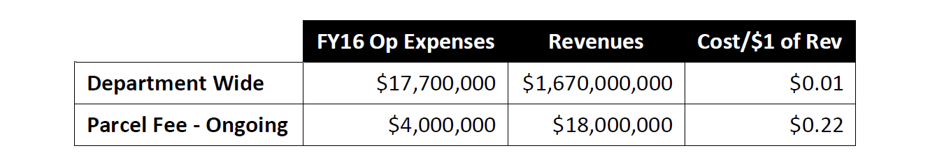

  - Local or regional stormwater utility option. Under this scenario, the Tax Department would support collection of a parcel or impervious surface fee by a regional or statewide stormwater utility. This would be similar to the first scenario, except that the Tax Department would need to develop new partnerships with local and regional utilities, rather than build upon existing relationships with municipal billing systems. Additionally, these new utilities would need to establish billing and collections capacities.

The Working Group was interested in obtaining additional information from existing stormwater utilities in Burlington and South Burlington about the number of appeals brought when stormwater billing systems were implemented.

- Revenues from Parcel and Impervious Surface Fees. The Working Group reviewed the Vt. Dept of Taxes Memo on “Parcel Fee Revenue Estimates, Memo Submitted to Treasurer (Nov. 2016).” In Fall 2017, the Treasurer asked the Tax Department how the state could raise roughly $18 million through four different methodologies: flat fee per parcel; per acre fee; a tiered impervious parcel fee; and a tiered impervious acre fee. It was noted that it is possible to mix and match the different options; for example, Burlington imposes a stormwater fee on commercial properties based on impervious acreage, and commercial property owners are required to update impervious data when they undertake improvements. The following table summarizes the four methodologies.
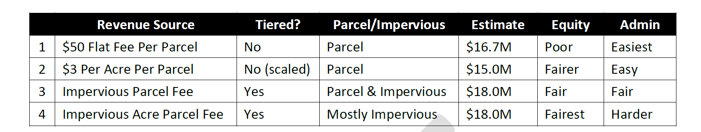

For the Act 73 Working Group, the Tax Department agreed to estimate the cost of a stormwater fee based on impervious acreage of each parcel. The impervious surface data, while not yet available statewide, should be available by SFY 2020.

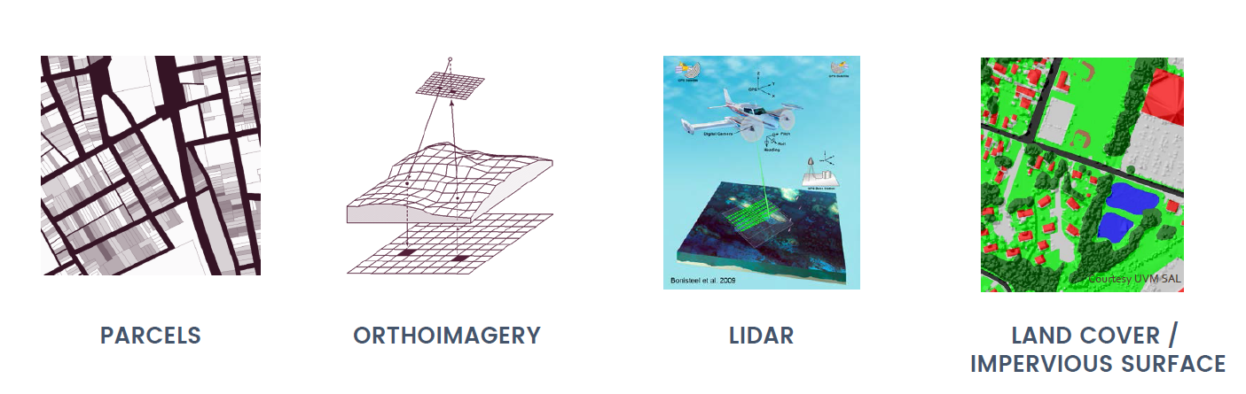
- Review Status of Geospatial Data. The Working Group reviewed a Powerpoint that was prepared by the Vermont Center for Geographical Information, “VCGI, Geospatial Data and Imagery Application, Powerpoint (Feb. 2017).” There are four mapping efforts currently underway. Notable estimated completion dates include:
- Parcel Data – Dec. 2020
- Land Cover/Impervious Surface (derived from orthoimagery and lidar data) – July 2018

It was noted that the cost of maintaining and updating land cover data on an annual basis will depend, in part, on whether algorithms can leverage lower-level resolution imagery to capture changes in of impervious surface. The technology related to image processing and land cover is evolving rapidly – thanks in part to work being done by the UVM Spatial Analysis Lab. Statewide Parcel map with an impervious surface overlay could provide more accurate estimates of impervious surface.

- Discussion of Administrative Options for Collection of Parcel or Impervious Surface Fees

  - Local administration.
    - Municipal considerations
      - Cost to administer (collection, mapping, appeals)
      - Towns do not bill “exempt” properties, but these properties should be included in system that bills stormwater fee
      - Appeals- should system replicate the property tax appeal process?
      - Vermont has high property tax burden, so fee should not be a property tax. Add comments from VLCT.
    - Currently, the state compensates towns in the amount of $5.7 million for assessment and collection of statewide property tax. Can VLCT develop an estimate of the additional cost to municipalities of administering an impervious surface fee?
      - Tax Dept and VCGI could deliver to towns impervious surface data that is linked with grand list data.
        - Exempt properties – State could link grand list data to impervious surface data collected by VCGI, including data on exempt properties.
      - Request for Information (RFI) is pending to modernize software related to the statewide NEMRC system.

  - State administration. State would take on both statewide property education tax and impervious parcel fee.
    - Costs. Tax Dept does not have a total cost estimate for this option, but has estimated the cost of collecting a property-based fee. This approach represents a fundamental change in how the statewide education property tax would be collected.
    - Scope is much larger than the current discussion of an impervious parcel fee.
    - Other considerations. Tax Department will develop a list of other considerations for discussion at July 28th meeting.

      - Property tax assessment – would this remain local or become statewide
      - Local municipal tax – would this be sent to the state and then reimbursed to the towns, or would municipalities continue to collect the local property tax

  - Parallel systems. Local collection of statewide educational property tax, complemented by statewide collection of parcel or impervious surface fee. Consensus was that this option is too expensive and should be discarded.

  - Local, regional, agricultural, or statewide utility system.
    - Purposes. Utility could raise revenues, spend money, or both.
      - Collect revenues
      - Efficiency in spending
    - Models
      - Local Municipal (current statutory authority exists)
      - Regional (example: solid waste districts model)
      - Statewide (example: Efficiency Vermont model. Allows for opt-out, such as Burlington Electric Department).
      - Agricultural Utility
        - Revenues – what would be the source of revenues for an agricultural utility?
    - VLCT has list of special purpose districts that will be shared with the group
    - Other Considerations
      - How does state ensure alignment of local spending on TMDL/clean water goals? (Tracking and accountability)

- Homework

- Matrix of options for parcel and impervious surface fee (DEC)
- Updated TMDL, CSO and Act 64 compliance costs estimates for 2020-2024:
  - Wastewater Treatment Facilities (including optimization) (DEC)
  - Transportation (VTrans)
  - Stormwater (DEC)
  - Agriculture (AAFM)

