Group Development

Phase 1: Identifying the five stages of group development
Now that you have identified your primary leadership style it is time to consider how your style fits into the group you work with. Understanding the different stages of group development will help you decide which leadership style to use and when. The five stages of group development; forming, norming, storming, performing, adjourning, are best considered as a cycle. The stages may not progress in a linear order, and they will likely reoccur if your group stays together.
Review the table on the following page adapted from Tuckman's Stages of Group Development, and consider what stage your organization/commission is currently in. What types of behaviors do you witness? What feelings and thoughts arise? and what leadership styles are being utilized?

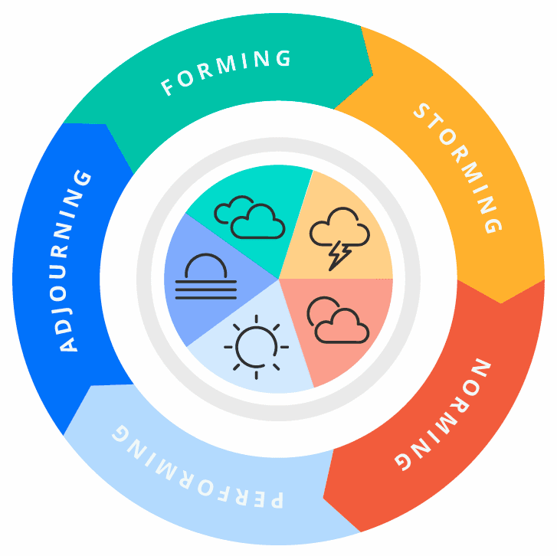
Picture credit: https://teamhood.com/team-performance-resources/team-development-cycle/

 | Behaviors | Feelings | Needs | Leadership Required
Forming  New group | - Politeness  - Tentative joining  - Avoid controversy  - Need for safety & approval  - Attempts to define tasks and processes | - Excited, optimistic, anticipation  - Suspicious, fearful, anxious  - What is expected of me?  - Why are they here? | - Mission/vision  - Specific objectives  - Identify roles & responsibilities  - Member expectations  - Operation guidelines | - Project guides & Instructors  - Provide structure & task direction  - Allow for “getting-acquainted” time  - Create atmosphere of confidence and optimism  - Active involvement
Storming  Conflict arises | - Arguing  - Vying for leadership  - Lack of role clarity  - Team organizing itself  - Power struggles  - Lack of consensus | - Defensive  - Confusion  - Resistance to tasks  - Tension/jealousy  - Unsure of personal freedom in team | - Relationship building  - Active listening  - Giving & receiving feedback  - Conflict resolution  - Clarify team’s purpose  - Reestablish roles & ground rules | - Acknowledgement of conflict  - Help forming consensus  - Give members more responsibility  - Teach conflict resolution methods  - Support & praise
Norming  Status quo | - Processes & procedures agreed upon  - Effective conflict resolution  - Consensual decisions  - Collaboration  - Creativity is high | - Sense of belonging  - Confidence  - Acceptance of all team members  - Trust  - Freedom to express and contribute | - Develop decision making process  - Sharing in problem solving process  - Sharing of leadership skills  - Feedback from project guides | - Shared leadership  - Feedback and support  - Allow for less structure  - Promote team interaction  - Encourage others to make decisions  - Foster relationships with all members
Performing  Peak performance | - Fully functional & independent team  - Self-organizing  - Flexibility  - Understanding of group processes | - Empathy  - Commitment  - Strong bonds between members  - Fun & Excitement  - Personal development  - satisfaction | - Move in collaborative direction  - Maintain flexibility  - Giving and receiving of information  - Feedback and dialogue amongst all members | - Hands-off leadership  - Observation  - Share new information  - Support and curiosity
Adjourning  Reflection & transference | - Signs of grief  - Big slowdowns in productivity  - Restlessness  - Bursts of energy followed by lack of energy | - Sadness  - Humor  - Relief | - Reflection  - Evaluate team efforts  - Tie up loose ends | - Celebration of achievements  - Active listening  - Provide options for transference  - Carry forth efforts and learnings to next opportunity

Phase 2: Facilitating movement through stages
As see in the table above, each stage comes with its unique set of team needs and leadership responsibilities. The best leaders will adapt their style to match the group’s stage and respect other leaders that may emerge. What the table does not explicitly address is the movement between stages. Not all groups make it to the performing stage. The groundwork that the leaders do in the early stages of group development is essential for long term success.
Cultivating an environment of creativity and productivity is easiest at the beginning of any project. It is worth spending the time early on to set the tone and build rapport among team members. One way to do this is by using the Drucker Exercise. Let’s try it now. Start by taking a few minutes to answer the following questions:
What am I good at?
How do I perform?
What do I value?
What can I contribute to this group or project?
Your responses to these questions are valuable information for you and anyone you wish to collaborate with. Making space in the forming phase for questions like these will help your team move more seamlessly through the stages of group development. In the storming stage this exercise will come in handy again. Here you will want to cater the questions to reflect the needs of a group in conflict. For example,
“What activates you?” (Aka what are the things that make you mad or sad?)
“What contributions to this project are expected of me?”
“What contributions do I expect from other members?”

*When true conflict does arise it is important that personal opinions are communicated in a way that neither shuts people down nor fires them up. Conflict resolution will be the topic of another activity later in Unit 2.

Take Aways:

-Groups are not instantaneously effective.
-Make space and put energy into developing a unique group culture.
-Be careful not to rush your team through the stages as this can easily backfire.
-Don’t settle! If your group is stuck in a stage reach out to team members individually and consider ways to move forward as a team.

References:

Tuckman’s Stages of Group Development:
https://www.wcupa.edu/coral/tuckmanStagesGroupDelvelopment.aspx#:~:text=These%20stages%20are%20commonly%20known,more%20collaborative%20or%20shared%20leadership

Drucker Exercise
https://backlog.com/blog/strengthen-team-using-drucker-exercise-tuckman-model/#:~:text=In%20this%20model%2C%20teams%20go,norming%2C%20performing%2C%20and%20adjourning.&text=Forming%20Stage%3A%20Members%20have%20just,team%20is%20not%20productive%20yet.

