Working Group on Water Quality Funding
National Life, Catamount Room
Wednesday, June 28, 2017
3:00-4:30

PROPOSED AGENDA

Introductions/Review Agenda

Statutory Mandate
Act 73 (2017), Section 26 (below)

FY18 Clean Water Funding
FY18 Summary of Total appropriations (by bill) (attached)
FY18 Summary of Costs and Revenues (by sector) (by type of property owner) (attached)

Discuss Focus Areas for this Report
Draft Table of Contents (attached)

Homework/Next Steps

Future Meeting Schedule/Deadlines
Friday, July 14 (9:00-10:30)
Friday, July 28 (9:00-10:30)
Friday, August 7 (9:00-10:30)
Friday, August 25 (9:00-10:30)
Early September (Meeting #1 with Advisory Council)
Early October (Meeting #2 with Advisory Council)
Early November (Meeting #3 with Advisory Council)
November 15 – Report Due

Act 73 (2017), Sec. 26. WORKING GROUP ON WATER QUALITY FUNDING

- Establishment. There is established the Working Group on Water Quality Funding to develop recommendations for equitable and effective long-term funding methods to support clean water efforts in Vermont.

(b) Membership. The Working Group shall be composed of the following six members:
(1) the Secretary of Natural Resources or designee;
(2) one member from the Vermont League of Cities and Towns, appointed by the Board of Directors of that organization;
(3) the Secretary of Agriculture, Food and Markets or designee;
(4) a representative of the Vermont Center for Geographic Information;
(5) the Commissioner of Taxes or designee;
(6) one member representing commercial or industrial business interests in the State, to be appointed by the Governor, after consultation with other business groups in the State;

(c) Advisory Council. The Working Group shall be assisted by an Advisory Council to be made up of:
(1) the State Treasurer or designee;
(2) the Secretary of Transportation or designee;
(3) one member from the Vermont Municipal Clerks and Treasurers Association appointed by the Executive Board of that organization;
(4) one member from the Vermont Mayors Coalition appointed by that organization;
(5) a representative of an environmental advocacy group appointed by the Speaker of the House;
(6) a representative of the agricultural community appointed by the Vermont Association of Conservation Districts; and
(7) a representative of University of Vermont Extension appointed by the President Pro Tempore of the Senate.

(d) Powers and duties. The Working Group on Water Quality Funding shall recommend to the General Assembly draft legislation to establish equitable and effective long-term funding methods to support clean water efforts in Vermont.

(e) Consultation with Advisory Council. The Working Group shall meet at least three times with the Advisory Council for input on the report to be submitted to the General Assembly under subsection (f) of this section. The Advisory Council’s comments shall be included in the final report.

(f) Report. On or before November 15, 2017, the Working Group on Water Quality Funding shall submit to the General Assembly a summary of its activities, an evaluation of existing sources of funding, and draft legislation to establish equitable and effective long-term funding methods to support clean water efforts in Vermont.

(g) Meetings.
(1) The Secretary of Natural Resources shall call the first meeting of the Working Group to occur on or before July 1, 2017.
(2) The Secretary of Natural Resources shall be the Chair of the Working Group.
(3) A majority of the membership shall constitute a quorum.
(4) The Working Group shall cease to exist on March 1, 2018.
(5) No specific state appropriations shall be used to support the working group or advisory council.

(h) Assistance. The Working Group on Water Quality Funding shall have the administrative, technical, and legal assistance of the Agency of Natural Resources and the Department of Taxes. The Working Group on Water Quality Funding shall have the technical assistance of the Vermont Center for Geographic Information or designee.

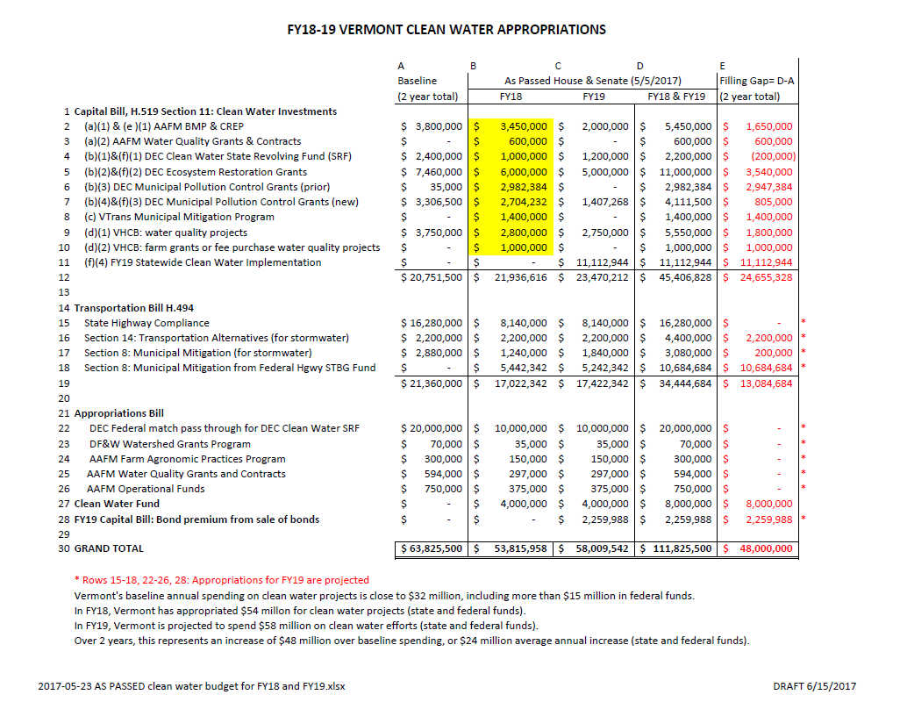
Treasurer’s Report – Tier I Gap (By Sector)
Annualized Average over 20 Years

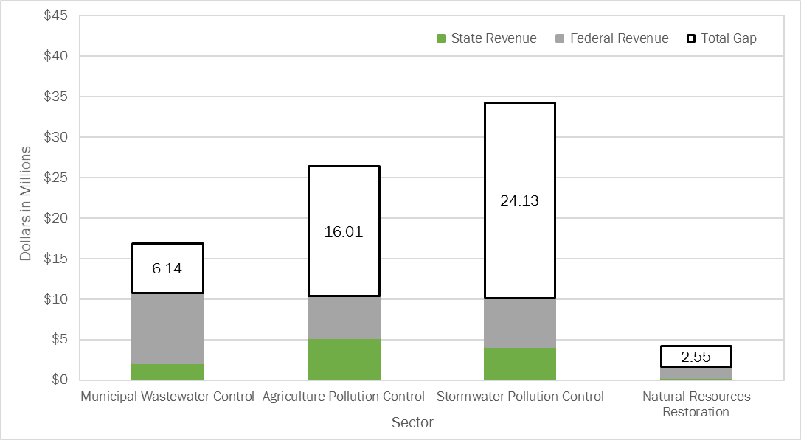

Tier I costs were estimated at $82.2 million a year; revenues were estimated at $33.7 million; leaving an annualized average gap in Tier I funding of $48.5 million ($6.14 + $16.01 + $24.13 + $2.55). Following the Treasurer’s recommendation, Governor Phil Scott proposed to fill half of this gap. Using general obligation bonds and federal highway funds, the Legislature appropriated a total of $53.8 million for clean water in FY18.

Treasurer’s Report - Tier I Gap (By Type of Property Owner)
Annualized Average over 20 years

Sector | Land Owner Type | Capital Bill Eligible?
Municipal Waste Water Control | Municipality | Yes
Stormwater - Municipal Roads | Municipality | Yes
Stormwater – Municipal Developed Lands* | Municipality | Yes (planning is not eligible)
Stormwater – State Highways | State | No
Stormwater – Private Land | Private | Eligible only if municipally sponsored (MS4)
Agriculture | Farmers | Limited
Natural Resources | All Types | Yes

*Assumes that DEC’s Ecosystem Restoration Fund will receive Capital Bill monies each year ($3.1 million annual average) to pay municipal costs to pay for stormwater retrofits of impervious surfaces greater than 3 acres.
FY18 TREASURER’S REPORT ESTIMATED COSTS &
FY18 STATE APPROPRIATIONS (DRAFT AS OF 4/7/2017)

Treasurer’s estimated costs (red bars) are based on what should be spent in FY18 in order to comply with TMDLs and state regulatory requirements. Funding and capacity constraints affect actual spending (blue bars). Earlier graphs show annualized average over 20 years; this graph shows Treasurer’s estimated FY18 costs. Where revenues exceed costs (mostly municipal roads), state will gain early compliance.

Revenues = $53.8 million in state budget (federal and state funds) + $5 million in USDA NRCS funds.

REPORT OF THE
WORKING GROUP ON WATER QUALITY FUNDING

H.516, SECTION 26

Submitted to the

General Assembly

by the

Vermont Agency of Natural Resources

November 15, 2017

Table of Contents
- Executive Summary
    - Statutory Mandate
    - Working Group Recommendations
    - Advisory Council Comments

- Treasurer’s Report: Estimating the Cost of Clean Surface Water
    - Total Annualized Average Cost over 20 Years
    - Sector #1: Municipal Wastewater and Combined Sewer Infrastructure
    - Sector #2: Agriculture
    - Sector #3: Developed Lands (Stormwater, Road Infrastructure Runoff, and Erosion Control)
    - Sector #4: Natural Resources Restoration

- Cost Revisions

- Revenues
    - General Obligation Bonds
    - TDI Transmission Line
    - Federal Highway Funds
    - NRCS Funds
    - VHCB Revenues
    - Parcel and Impervious Surface Fees
    - Phosphorus Trading & Impact Fees
    - Revenue Sources Discussed During Treasurer’s Report Stakeholder Process

- Financing
    - Clean Water State Revolving Fund (CWSRF)
    - USDA Rural Development

- Matching Costs with Revenues and Financing Methods
    - Sector #1: Municipal Wastewater and Combined Sewer Infrastructure
    - Sector #2: Agriculture
    - Sector #3: Developed Lands (Stormwater, Road Infrastructure Runoff, and Erosion Control)
      - Municipal Roads (Municipal General Roads Permit)
      - Municipal Developed Lands (> 3 acres)
      - State Roads (Transportation Separate Sewer and Stormwater System) (TS4)
      - Private Developed Lands (> 3 acres)
    - Sector #4: Natural Resources
Appendices
- Text of H.516, Section 26
- Comments of the Advisory Council to the Working Group on Water Quality Funding
- Complete list of revenues suggested by Treasurer’s Stakeholder Groups

